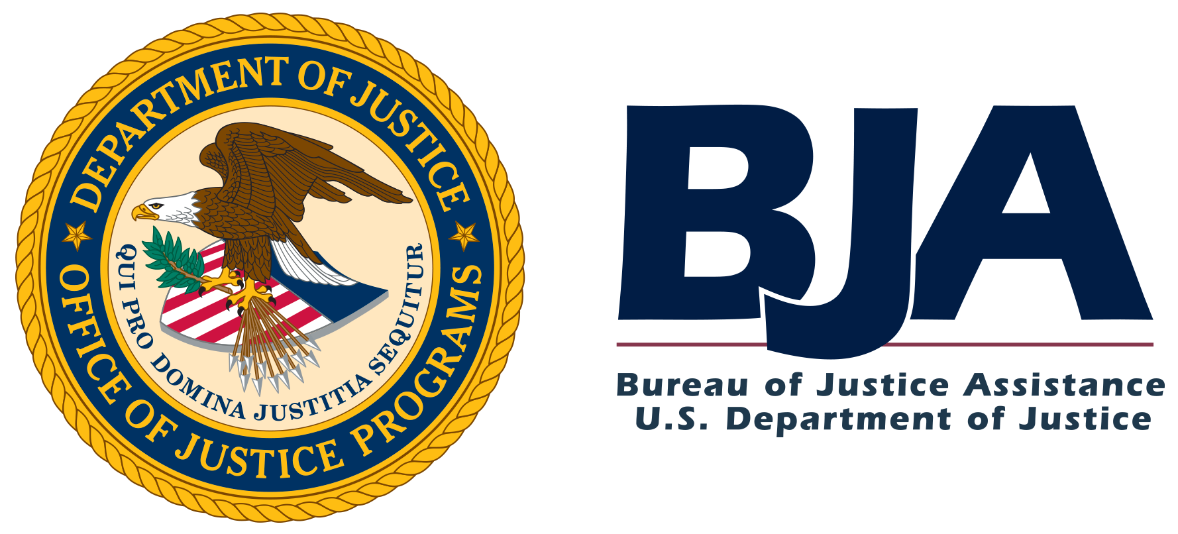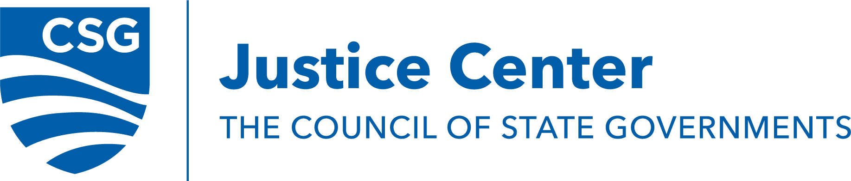

Call for Applicants to Participate in the
Criminal Justice-Mental Health Learning Sites Program

In partnership with the U.S. Department of Justice’s Office of Justice Programs’ Bureau of Justice Assistance (BJA), The Council of State Governments (CSG) Justice Center is seeking applicants to join the national Criminal Justice-Mental Health Learning Sites Program.
Ten to 12 programs will be selected and gain national recognition as members of the Criminal Justice-Mental Health Learning Sites Program. These sites will work closely with the CSG Justice Center to provide peer-to-peer learning and mentoring opportunities to programs nationwide. While learning sites do not receive funding directly from BJA or the CSG Justice Center, they are reimbursed for approved costs associated with hosting site visits from other jurisdictions or travel to other jurisdictions to provide training and technical assistance. They also have access to no-cost, expert technical assistance provided by CSG Justice Center staff.
Priority will be given to applicants that are using innovative practices and are leading the field with interventions to reduce contact with the criminal justice system and recidivism for people who are involved in the criminal justice and behavioral health systems.

Deadline
All applications are due by 11:59 p.m. ET on February 10, 2023 (See “Deadline,” page 3).

Contact Information
For assistance with submitting an application, please contact Katie Herman, senior policy analyst in the Behavioral Health Division, at kherman@csg.org.

Contents
Overview of Learning Sites Program 2
Eligible Agencies 3
Deadline 4
Application Process 4
Selection Criteria 5
Application 7

- Overview of Learning Sites Program
Communities across the country are exploring innovative models to respond to the needs of people with mental illnesses, reduce their criminal justice contact, and connect them to treatment and services. However, there is an increasing need for programs that can serve as model sites and provide peer-to-peer learning based on their experience and the practices they have implemented.

The Criminal Justice-Mental Health Learning Sites will consist of sites that have implemented diversion and/or other interventions that aim to reduce criminal justice contact and improve health and wellbeing for people with behavioral health conditions (for example court-based diversion, jail-in reach services, mental health courts, etc.). These sites will also have expertise and experience at various points in the Sequential Intercept Model to ensure a range of diversion programs are represented. (See Behavioral Health Diversion Interventions: Moving from Individual Programs to a Systems-Wide Strategy and the Justice and Mental Health Collaboration Program’s Overview section on Interventions, Descriptions, and Promising Approaches for additional context and examples of the types of programs and interventions that could be selected as learning sites across the Sequential Intercept Model.)

Following a competitive application process, selected jurisdictions will gain national recognition as members of the Criminal Justice-Mental Health Learning Sites Program. They will work closely with the CSG Justice Center to provide peer-to-peer learning and mentoring opportunities to programs nationwide. They may also be called on to collaborate with fellow learning sites and stay abreast of current research and best practices. While learning sites do not receive funding directly from BJA or the CSG Justice Center, they are reimbursed for approved costs associated with hosting site visits from other jurisdictions or travel to other jurisdictions to provide training and technical assistance. They also have access to no-cost, expert technical assistance provided by CSG Justice Center staff.

Programs must be willing to serve as and fulfill the duties of learning sites, including but not limited to:
- Responding to questions from the field in a timely and thoughtful manner;
- Hosting site visits with interested jurisdictions and providing brief summaries of these visits to the CSG Justice Center;
- Engaging in CSG Justice Center-hosted peer-to-peer learning activities (e.g., web meetings, webinars, conference calls, and conference presentations); and
- Consulting with the CSG Justice Center on projects or publications relevant to their program expertise.
Note: the Criminal Justice-Mental Health Learning Sites Program will not include police-mental health collaboration programs at this time as those programs are represented in the nationally-recognized Law Enforcement-Mental Health Learning Sites Program.
- Eligible Agencies
The following types of programs and agencies are eligible to apply to the learning site program. A diversity of programs will be chosen as learning sites. Agencies may only apply for one category at this time.
  - Community responder programs (see Expanding First Response: A Toolkit for Community Responder Programs for examples)
  - Crisis stabilization centers
  - Tribal Healing to Wellness Courts (see Tribal Healing to Wellness Courts for more information)
  - Pre-sentencing behavioral health and substance use need programs that use a validated risk and responsivity screening tool (see Advancing Fairness and Transparency: National Guidelines for Post-Conviction Risk and Needs Assessment for additional information about risk, need, and responsivity)
  - Pretrial release programs with a focus on behavioral health and/or substance use
  - Diversion programs for people with serious mental illness and/or habitual substance use
  - Pretrial competency programs, including:
    - Community-based competency programs
    - Jail-based competency programs
    - Diversion programs for competency cases
  - Behavioral health providers in a jail setting
  - Behavioral health jail reentry programs
  - Behavioral health prison reentry programs
  - Mental health courts
  - Agencies that use specialized probation or parole caseloads
- Deadline
All applications are due by 11:59 p.m. ET on February 10, 2023. Applications must be submitted by email to Katie Herman at kherman@csg.org.

IV. Application Process
Please review the following application process and email your completed application to Katie Herman at kherman@csg.org by 11:59 p.m. ET on February 10, 2023.
  - Submit:
    - A letter of interest
    - The completed application
    - Requested supplementary materials
A letter of interest must be submitted by program leadership to Katie Herman, senior policy analyst. The letter of interest should address:
- Why you are interested in becoming a nationally recognized learning site;
- How the program would incorporate learning site duties (including responding to questions from the field, hosting site visits, visiting with jurisdictions that request assistance, reporting summaries of monthly activities to the CSG Justice Center, and engaging with peers); and
- How the program meets the selection criteria outlined in Section V.
This letter should be double-spaced, using a standard 12-point font with not less than 1-inch margins, and should not exceed 3 pages.
Applicants must also submit a completed application (Section VI) and the requested supplementary materials.
  - Telephone interviews
After all applications received by February 10, 2023, are reviewed, a subset of sites will be selected as finalists based on the quality of the applications submitted and how well the sites demonstrate that they meet the selection criteria in Section V. The CSG Justice Center will then schedule follow-up calls to inform the final selection of learning sites.
  - Final selection
Based on the letter of interest, application, supporting materials, and information obtained through the telephone interview and/or on-site observation, the CSG Justice Center will identify sites that best fit the selection criteria and have the greatest capacity to serve as learning sites.

All application materials and findings, as well as recommendations, will be presented to BJA, CSG Justice Center staff, and outside expert consultants for final review and confirmation.

- Selection Criteria
Learning sites will be selected to ensure there’s diversity in the programs that meet the following criteria. The information below should be conveyed in the letter of interest and application.
1. The agency or program uses equitable practices and policies that focus on collaborative community involvement. To demonstrate this, sites must:
- Provide a list of diverse community partners committed to the project,
- Outline how equity and inclusion in purpose, approach, and practice are incorporated in core program components,
- Provide the existing framework for a readiness-to-change community action plan that is based on an assessment of the community’s needs,
- Provide a statement that centers equitable practices in the agency’s organizational policies and service delivery, and
- Provide a statement of your agency’s ability to incorporate cultural responsiveness and the community voice into your programming.
2. The agency or program participates in a collaboration between behavioral health and criminal justice partners. To demonstrate this, sites must:
- Explain how the behavioral health and criminal justice partners work together to establish and provide ongoing support for this program/project; and
- Provide a list of behavioral health and criminal justice stakeholders involved in project, showcasing an established community stakeholder taskforce.
3. The agency or program uses innovative approaches to provide services to participants. To demonstrate this, sites must:
- Outline how their programming is based on principles that have been documented to be successful for the population the agency/program serves;
- Provide a description of the program design and delivery approaches, the population being served, and details about how the program stands out from other programs doing similar work;
- Provide evidence of a trauma-informed program design; and
- Showcase how they use culturally responsive community measures of success and culturally responsive risk and needs screening instruments.
4. The agency or program can provide documentation of intended strategies and can describe the program’s expected and/or desired outcomes.
5. The agency or program has been in operation for at least 18 months, and the program has a sustainability plan in place. To demonstrate this, sites must:
- Provide details about the sustainability plan (see Financing the Future of Local Initiatives for additional details on financial sustainability), including its function, responsible persons, and a timeline for performance; and
- Describe the agency’s infrastructure currently in place to operationalize the plan.
6. The program or agency has the ability, capacity, and interest to teach and train other organizations about their program’s implementation, policies, procedures, and sustainability. To demonstrate this, sites must:
- Offer a plan for how they will respond to learning site technical assistance requests, provide quarterly data and narrative reports to CSG Justice Center on technical assistance provided to sites around the country, and participate in coordination calls with other learning sites;
- Provide examples of past program consultation they have provided and to whom;
- Provide copies of program manuals, policies, and procedures; and
- Describe the agency’s proposed protocol for answering questions from CSG Justice Center, BJA, or other sites around the country.

VI. Application – Submit no later than February 10, 2023, at 11:59 p.m. ET.
Complete the application form, providing as many details as possible to each question. If you have questions or concerns, please e-mail Katie Herman at kherman@csg.org.
Contact information
Name
Title
Agency
Address
Telephone
E-mail

Program information
- Please indicate your program type (select only one):
Program Type | Community responder program  Crisis stabilization center  Tribal Healing to Wellness Courts  Pre-sentencing behavioral health and substance use needs program that uses a validated risk and responsivity screening tool  Pretrial release program with a focus on behavioral health and/or substance use  Diversion program for people with serious mental illness and/or habitual substance use  Pretrial competency program (whether community-based, jail-based competency, or diversion)  Behavioral health provider in a jail setting  Behavioral health jail reentry program  Behavioral health prison reentry program  Mental health court  Agency that uses specialized probation or parole caseloads

- Briefly describe your program including its mission, length of operation, and population of focus. (750 words or fewer)
- How is your program funded? (250 words or fewer)

- Describe why your agency would make a good learning site based on the selection criteria above. (750 words or fewer)

Services

5) In what ways does your program use innovative approaches to provide services to participants? Provide a description of the program’s design and delivery approaches and how the program stands out from other programs doing similar work. (750 words or fewer)

6) What types of culturally responsive evidence-based practices does your program use? (500 words or fewer)

- How does your program use a trauma-informed program design in its service delivery? (500 words or fewer)

8) What risk and responsivity screening instrument(s) does your program use? (500 words or fewer)

Partnerships

9) List any and all criminal justice, mental health, and other community-based service provider partners who were involved in the design, planning, and implementation of this program.

10) Describe the role of these partners in the design and operation of the program. (500 words or fewer)

Equity and Community Involvement
11) How does your program use equitable practices and policies to meaningfully involve the community in your program? (500 words or fewer)

12) Provide a statement that demonstrates how your program centers equitable practices in its organizational policies and service delivery. (500 words or fewer):

13) Provide a statement of your agency’s ability to incorporate cultural responsiveness and the community voice into your programming (500 words or fewer):

14) What are some examples of positive outcomes or impact your program has had on the community at large? (750 words or fewer.)

Data Collection and Information Sharing
15) What data are collected by your program? (500 words or fewer) Attach your program data overview in a report format.

16) How are data used to inform program practices? (500 words or fewer)
Financial Sustainability

17) What is your program’s financial sustainability plan? Include in your response details on: who is responsible for the plan and what is the plan’s timeline for assessing and improving performance? (500 words or less). Provide a copy of the plan as an attachment.

18) Describe the systems and staffing currently in place to operationalize your sustainability plan. (500 words or fewer)

Technical Assistance Requests
19) How does your program plan to respond to learning site technical assistance requests? Provide examples of past program consultation you have provided and to whom. (500 words or less)

Additional information
20) Please provide any additional information about your program, including any other elements that you believe are particularly strong and of value for other agencies to understand. This may include any information that demonstrates program sustainability, training and protocols for staff, information-sharing policies, or any strong peer-support features. (Optional)

- Attachments

Supporting Materials
The following items must be submitted to Katie Herman at kherman@csg.org by February 10, 2023, at 11:59 p.m. ET.
Please submit the following required materials:
- Letter of interest
- Completed application
- Policy and procedures documents (e.g., written policies, tools, or guidelines that support any of your answers)
- Examples of past program consultation provided and to whom
Optional materials:
- Any annual reports and/or program brochures
- Program evaluations (either internal or from a third-party evaluator)
- Other materials that support responses on application

